***CIS 311 – Assignment 9***

Over the last week or so, we’ve journeyed into COM automation and object-orientation. This week’s program is going to perform a bunch of statistical analyses for a big box electronics firm. You have the 50 stores in the firm’s chain stored in the file stores.txt on Canvas. Each line in the input file, which is comma separated, consists of the following information: store number, current sales amounts for each month from January through December, and the last number on each line is the total sales for that particular store from the previous year. You should create a class to hold the relevant store information from the file (and you should ONLY store the information that is in the file in the class – Excel will be doing all of the heavy lifting). The class only needs a named constructor that will fill these items with data upon instantiation. No other methods are to be written other than the constructor and the getter/setters for the attributes.

You will then create a series of Store objects (you can do this by hardcoding the values from the file into your code) in a manner similar to:

myStores.Add(New clsStore(1, {107331, 92231, 111935, 110259, 109737, 102424, 129570,

106814, 136820, 118783, 94460, 119138}, 1366292.04))

myStores.Add(New clsStore(2, {91788, 89729, 110009, 127497, 124784, 97200, 142515,

148578, 150357, 131487, 130637, 111603}, 1427060.32))

.

.

.

myStores.Add(New clsStore(49, {100733, 101238, 105049, 113079, 94012, 114502, 148437,

117958, 138357, 107346, 94000, 105164}, 1192488.75))

myStores.Add(New clsStore(50, {110373, 91972, 105491, 129809, 98560, 119508, 133539,

116210, 123899, 118077, 121321, 108584}, 1515077.3))

Make sure the class file is well designed with the appropriate setters/getters/properties implemented as needed.

For the second part of the assignment, we want to push the data from the classes into Excel using automation. Make sure you add a reference to the Microsoft Excel Object Library. Put header information into the first row of your spreadsheet. Here is what the various columns should contain value-wise:

* Column A will contain the store number
* Column B through M contain the current 12 month sales values
* Column N contains the average of the current 12 month sales
* Column O contains the total of the current 12 month sales
* Column P contains the previous year’s total sales
* Column Q contains the sales variance (current year total / previous year total)
* Column S contains the three month sum for Jan – Mar of the current year
* Column T contains the three month sum for Apr – Jun of the current year
* Column U contains the three month sum for Jul – Sep of the current year
* Column V contains the three month sum for Oct – Dec of the current year

After you have processed all of the rows of data, you should skip one row and then add in an average row, total row, min row and max row, so that all columnar data will also have statistical data (skip the empty R column though). You should be writing Excel formulas to do the statistical work in the columns and rows. If you don’t write formulas (and ensure that you make them dynamic because I will be using different data), you will lose points! Nothing in the program should have to be rewritten because the spreadsheet should always generate correctly based on the data presented to it. Here’s a few screenshots after processing the data:

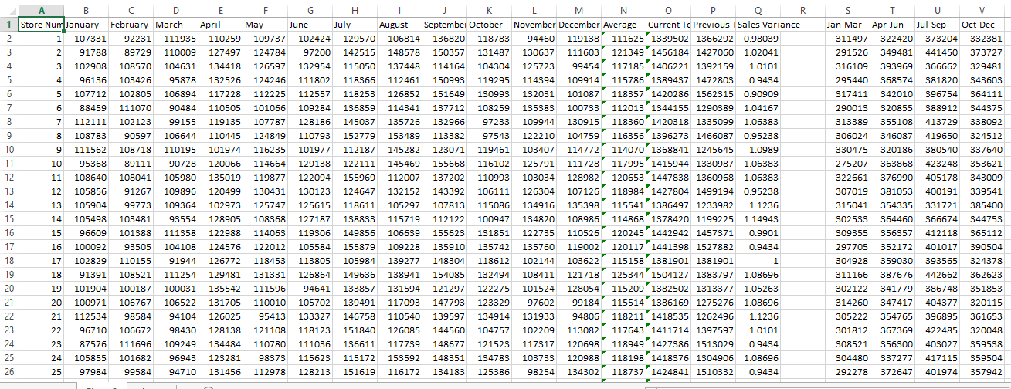

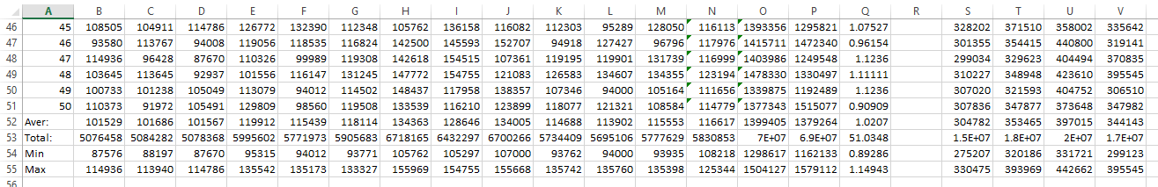

Complete your assignment and place your entire solution in a zip file, which you will upload to Canvas. Turn in a cover sheet and screenshots of your program’s execution stapled together in that order in class.